Paseo de las Montañas
Paseo de las Montañas Trail follows the concrete-lined Piedra Lisa and Embudo arroyos through Northeast Heights suburbs and their spacious public parks. We’ll explore aspects of the area’s neighborhoods, architecture, geology, hydrology, and natural history, as well as the history of its development. Those willing to slow down, look into yards, and briefly leave the path will be treated to local art, both public and home grown.
The east end of the tour lies near the intersection of Menaul and Tramway boulevards while the western terminus is extended beyond the channel to include Jerry Cline and Tom Bollack parks, as well as a short stretch of street-side bike route running to San Pedro Drive.
As an optional side tour, we’ll ride the trail along Embudo Arroyo from Tramway to its junction with Paseo de las Montañas.
Note: A City bike map is handy if you plan to leave the tour and follow one of the many connecting routes. You can pick up a map from most bike stores, from the city, or you can find an interactive map here: http://www.cabq.gov/parksandrecreation/recreation/bike/bike-map. Some of the bike routes shown on the map and discussed here are not signed on street.
Parking
Embudo Canyon, Open Space Trailhead. On Menaul 0.6 miles east of Tramway.
0.3Miles/ 5.3 Miles. Lynnewood Park. Curbside parking along the park perimeter.
1.1 Miles/4.5 Miles. Ross Enchanted Park. Curbside parking along the park perimeter.
2.8 Miles/2.8 Miles. Snow Park. Curbside parking along the park perimeter.
4.7 Miles/0.9 Miles. Jerry Cline Park.
5.3 Miles/0.3 Miles. Tom Bolack Urban Forest. Street parking available.
For the Embudo Arroyo side trip, parking is available curbside on the north end of Crestview Heights Park, 0.1 miles from the start. Also, the starting point is 0.7 miles north of Indian School Road and 0.5 miles south of Menaul; both streets end at parking lots less than a mile east of Tramway.

East side of the wooden overpass on Tramway Boulevard. The overpass is 0.3 miles north of Menaul Boulevard. You can reach this point by riding the Tramway Trail (see Tramway tour), coming from the north or south. Parking is available at the Embudo trailhead at the end of Menaul Boulevard, 0.6 miles east of Tramway.
- Miles From Tramway Boulevard
  - Miles From San Pedro Drive
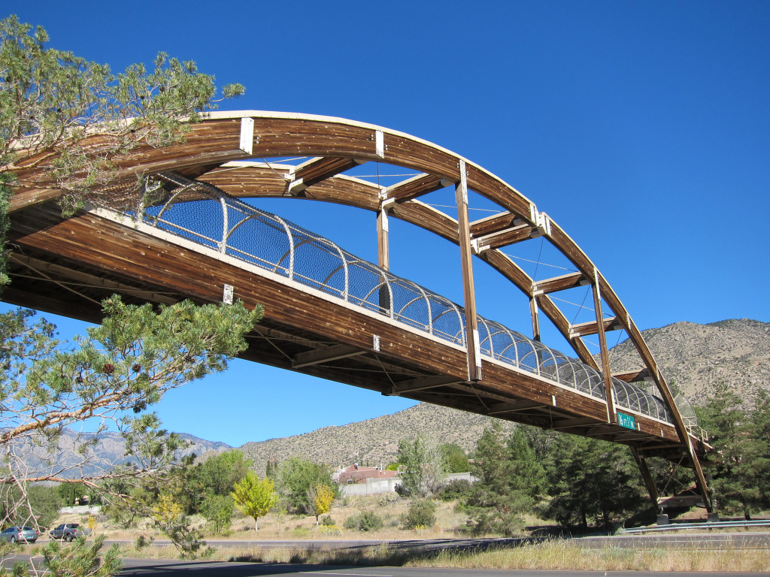
Go west across the overpass and at the bottom of the ramp make a 180 degree turn, go several hundred feet and turn left down Piedra Lisa Arroyo. Lettering on the pavement indicates you are entering the Paseo de las Montañas trail. If you go straight instead of turning sharply at the bottom of the ramp, you will quickly reach Lexington Avenue, a good east-west bike route, which includes several other short stretches of road as well as Claremont Avenue. The route runs to a point a few blocks west of Carlisle Boulevard.
Laminated Wood Overpass
Lynnewood Park straddles the trail, offering large shady trees, picnic tables, a playground, and tennis courts, with parking available curbside along the park perimeter. At the west end of the park cross Nakomis Drive and continue down alongside the arroyo.
0.3 Miles
5.3 Miles
Lynnewood is the first of several parks we will visit having an arroyo running through it. The presence of drainages in many Heights public facilities is not a coincidence, and an explanation of its origin leads to a larger exploration of park development in the Heights. The brief summary that follows is based on interviews with and writings of Janet Saiers, retired Parks and Recreation staff person and city parks historian.
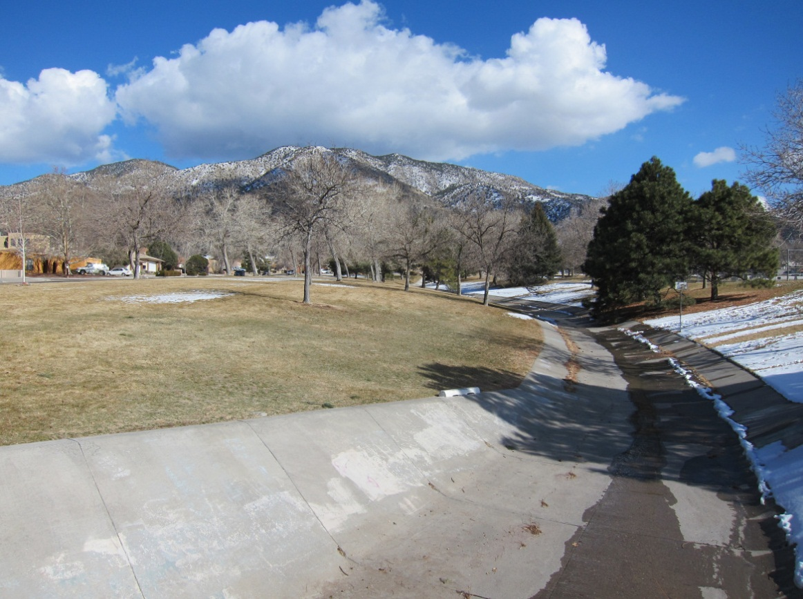
By the mid 1950’s, Albuquerque’s post-war housing boom had started. What was then the Albuquerque city commission, seeing the need to include parks in the suburbs spreading to the northeast, created the Parks and Recreation Board along with the position of director to plan for and administer park development. In 1955 the city commission passed the City Park Dedication Ordinance, requiring developers to give a small percentage of their land to the city for parks. With no explicit criteria regarding the location of donated land, and without enough park staff to evaluate possible sites, the city relied on the builders, who chose to allocate arroyos and adjacent land—sites that were not suitable for homes. While there was some logic to this arrangement, it did not guarantee that parks would be centrally located and convenient. Furthermore, the city had to pay to stabilize the channel. The city was also responsible for park improvement, and without funding to do more, the parks’ amenities consisted primarily of a few swings and steel “monkey bars.”
Lynnewood Park And Piedra Lisa Arroyo

The mid to late 70’s saw several important changes. First, developers were required to dedicate park land based on the number of dwellings built (including apartments) and to pay a fee to help defray the cost of park development. Second, with more park staff available, the city was able to be selective in determining the park location. Finally, the city began employing landscape architects to create more complex, comfortable and attractive facilities.
In 1993, the state legislature passed the Development Fee Act, allowing local governments to charge impact fees for new developments. Among other kinds of infrastructure, these fees could be used for a variety of recreation facilities, including trails, pools, and tennis courts.
Albuquerque citizens value their open spaces and over the years have shown support by passing bond issues for many improvements.
Chelwood Park Boulevard. A bike lane for much of Chelwood along with connecting bike routes (see map), provides access to Tramway and Montgomery Boulevards to the north and Tramway, Cloudview Avenue, and Encantado Road to the south.
0.7 Miles
4.9 Miles

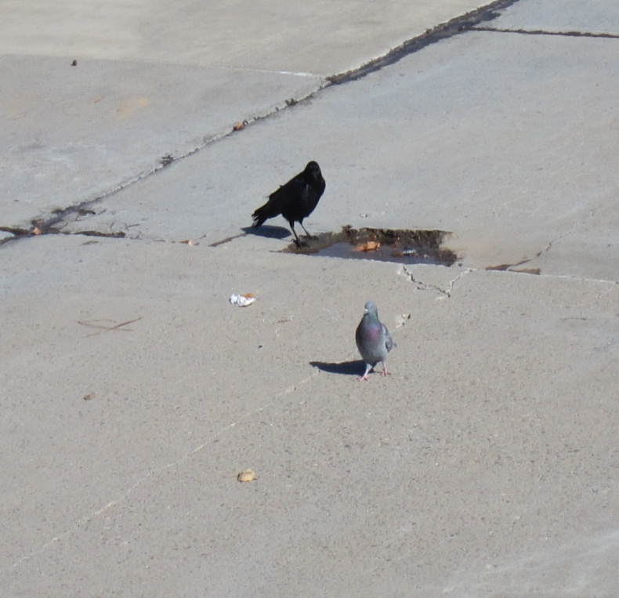
One will occasionally see a squirrel sunning itself on the sloping walls of the arroyo as well as birds foraging in the bottom, a reminder that wildlife can utilize even this sterile concrete environment. Brandon Griffith of the State Department of Game and Fish notes that much larger animals, including bear, deer, mountain lions, coyotes, and bobcats also use the channels as travel corridors, primarily east of Tramway but sometimes moving farther west, where they encounter neighborhood residents, traffic, and inevitably, state wildlife officials.
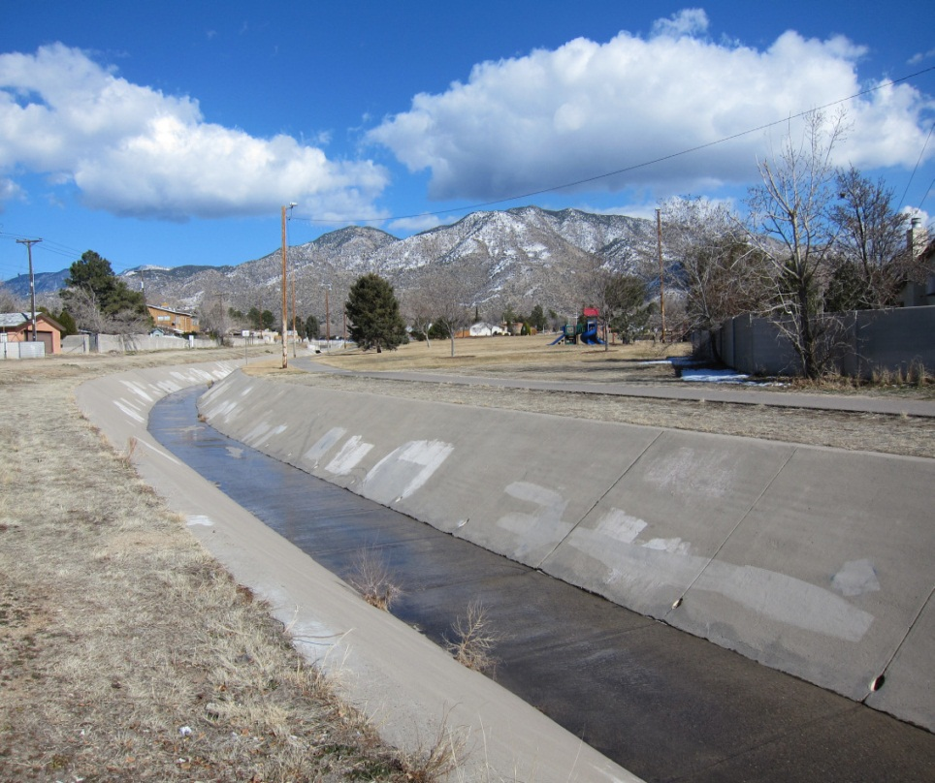
Ross Enchanted Park. With its grassy expanses, shade, a picnic table, playground and benches, the park is an inviting public space for residents as well as cyclists passing through. Robert Trudo, president of the Enchanted Park Neighborhood Association notes that the well used park is especially lively at Easter when the neighborhood children unearth some 2,000 Easter eggs hidden in the park, needing only about 10 minutes to locate them all. Robert says the public is invited to participate in the hunt. He describes his neighborhood as a cohesive one, in which neighbors communicate with each other and with the city. Early in the 2000’s, the park was just grass and trees, but the association, working through its city councilor, obtained funding for the other amenities, including lighting for the trail along the arroyo.
Ross Enchanted Park And Piedra Lisa Arroyo

1.1 Miles
4.5 Miles
Wildlife In The Arroyo
Wildlife In The Arroyos
Parking is available curbside along the park perimeter.
These tours celebrate the bicycle and its usefulness for recreation and transportation. But the guides also examine larger aspects of our culture and history and an undeniable aspect of our culture—as evidenced by the houses we pass here and elsewhere in the Heights—is the significance of the automobile. Architecturally, the prominence of cars in the Heights contrasts starkly with the early-developed neighborhoods just east of downtown—housing which was served by electric trolleys prior to the coming of cars. As we see throughout much of the Heights, later development is typified by the garage as an architectural element integral to the house and one that “balances” the rest of the structure. Garages in older neighborhoods are often much smaller, separate, and located toward the rear.
Juan Tabo Boulevard. A protected median allows you to safely cross one side at a time.
1.2 Miles
4.4 Miles
Donald A. Gil’s book, Stories Behind The Street Names Of Albuquerque, Santa Fe, & Taos, is this guide’s source of information about Albuquerque street names. He notes that the identity of Juan Tabo has not been satisfactorily determined.
Menaul Boulevard. A protected median allows you to safely cross one side at a time.
1.6 Miles
4 .0 Miles
The street was named for the Menaul School, located at Broadway and Menual Boulevard. The school was named for Reverend James Menaul, synod executive of the Presbyterian Church of New Mexico; he was active in school affairs during the 1890’s. For more information about the school, see the North Diversion Channel Tour.
Trail temporarily ends. Turn left on Martha Street, and then quickly turn right on Gretta Street, which takes you past Collet Park and Collet Park Elementary School. Turn right on Snowheights Boulevard and in a few hundred feet turn left to return to the trail.
1.7 Miles
3.9 Miles
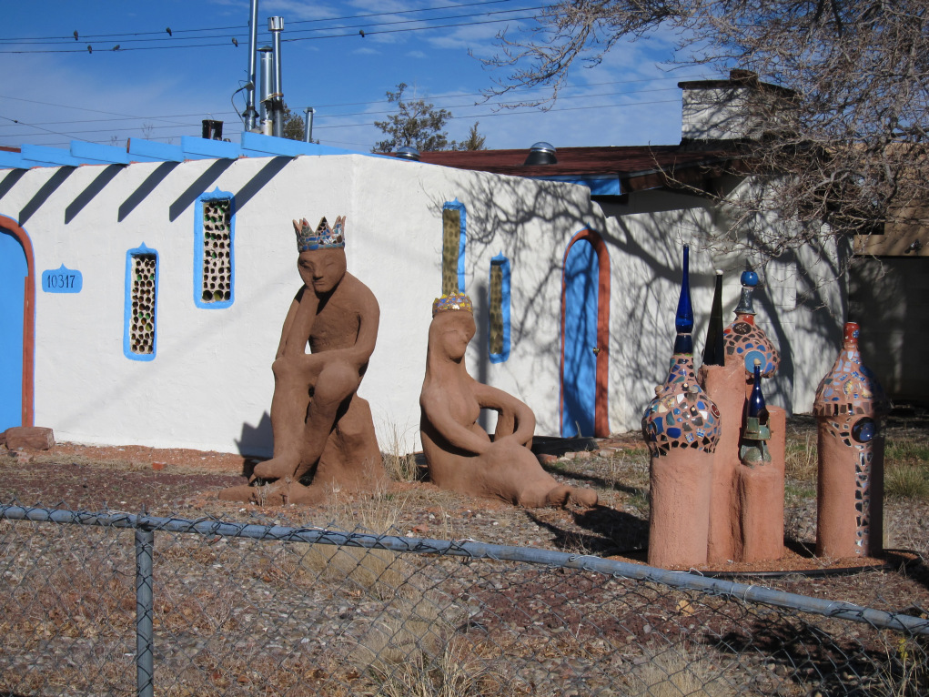
Snow Heights neighborhood was named after Edward H. Snow, owner of Snow Construction, Inc.. Snow, Dale Bellamah and Sam Hoffman were among the first of the postwar builders to implement large-scale development, utilizing relatively cheap and extensive tracts of land along with mass production techniques. By the mid 1950’s, Hoffman’s and Bellamah’s corporations were respectively, the fourth and sixth largest home construction companies in the world. Development was further stimulated by the city’s program of aggressively annexing peripheral land and then extending city services. Also, FHA loans, a program created during the Great Depression, had made home purchase far more accessible to the growing middle class.
Just Off The Trail. N W Corner of Morris And Menaul

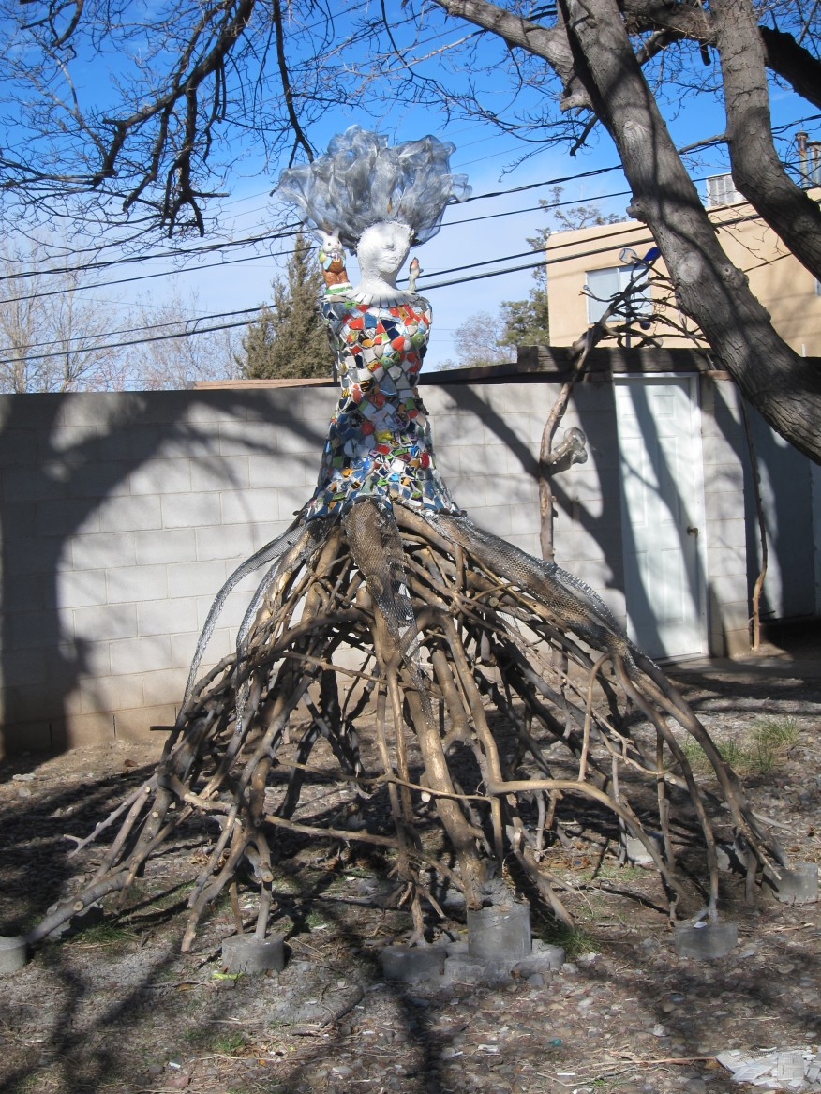
Just Off The Trail. N W Corner Of Morris And Menaul

Embudo Arroyo, Morris Street. The trail crosses a bicycle/pedestrian bridge over Embudo Arroyo, meeting the Embudo Trail (see side trip), and immediately intersects Morris Street. The Morris Street bike lane runs as far north as Spain Road, and as far south as Constitution Avenue. From Constitution, you can continue south on bike routes and an I-40 bicycle/pedestrian overpass to Manzano Mesa Park south of Central.
2.0 Miles
3.6 Miles

East of Eubank

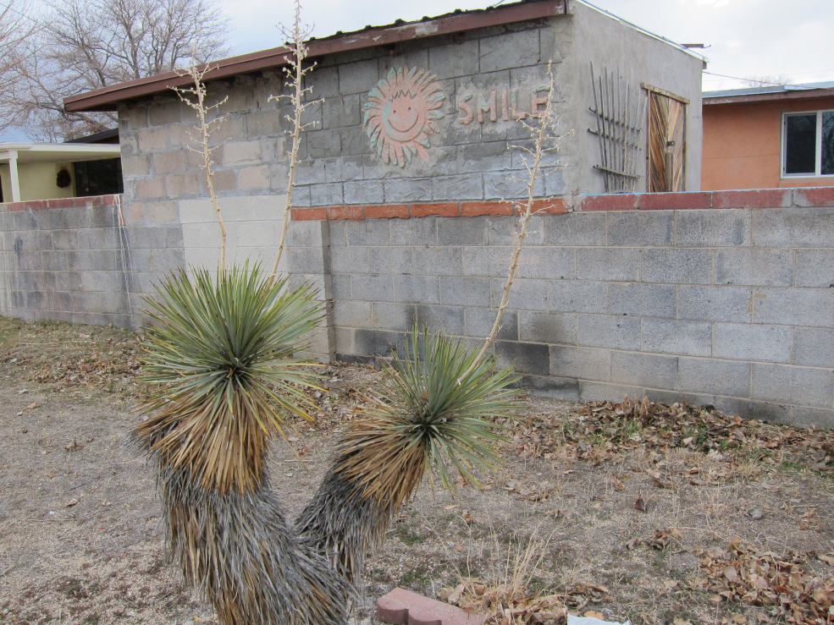
Eubank Boulevard. Embudito Arroyo (no bike path) joins our route here. A protected median allows you to safely cross one side of Eubank at a time.
East of Eubank
2.5 Miles
3.1 Miles

Lt. Colonel Eugene L. Eubank was the commander of army’s 19th Bombardment Group. In 1941, he and his crews were sent to train at the Albuquerque Army Air Base, (later renamed Kirtland Air Force Base), before being sent to the Philippines.
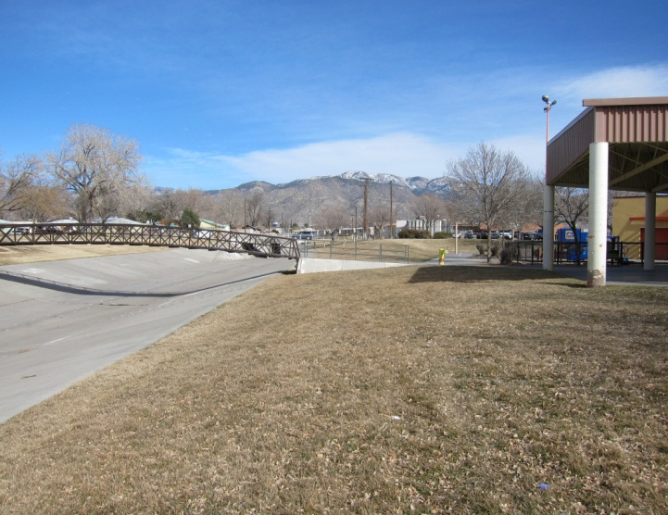
Parsifal Street Turn right onto Parsifal and just over the bridge turn left to rejoin the trail on the other side of the arroyo. The trail runs through Snow Park with its grassy fields and playground. Curbside parking is available along the park perimeter.
2.8 Miles
2.8 Miles
Indian School Road. A protected median again allows you to cross one side at a time. Using the Indian School Road bike lane plus connecting routes, you can travel east to Tramway Boulevard and west to Broadway.
Snow Park And Embudo Arroyo

3.0 Miles
2.6 Miles
The road is named after the Albuquerque Indian School, (officially known as the United States Indian Training School), founded in 1881, first located in the Los Duranes district, and initially operated by the Presbyterian Church. A “permanent” location was secured by the Department of Interior when local businessmen donated a former farm site at 12th Street and Indian School Road. In 1982, the boarding school closed and its operations were transferred to the Santa Fe Indian School. The old school buildings have since been demolished and the currently vacant land is undergoing re-development.
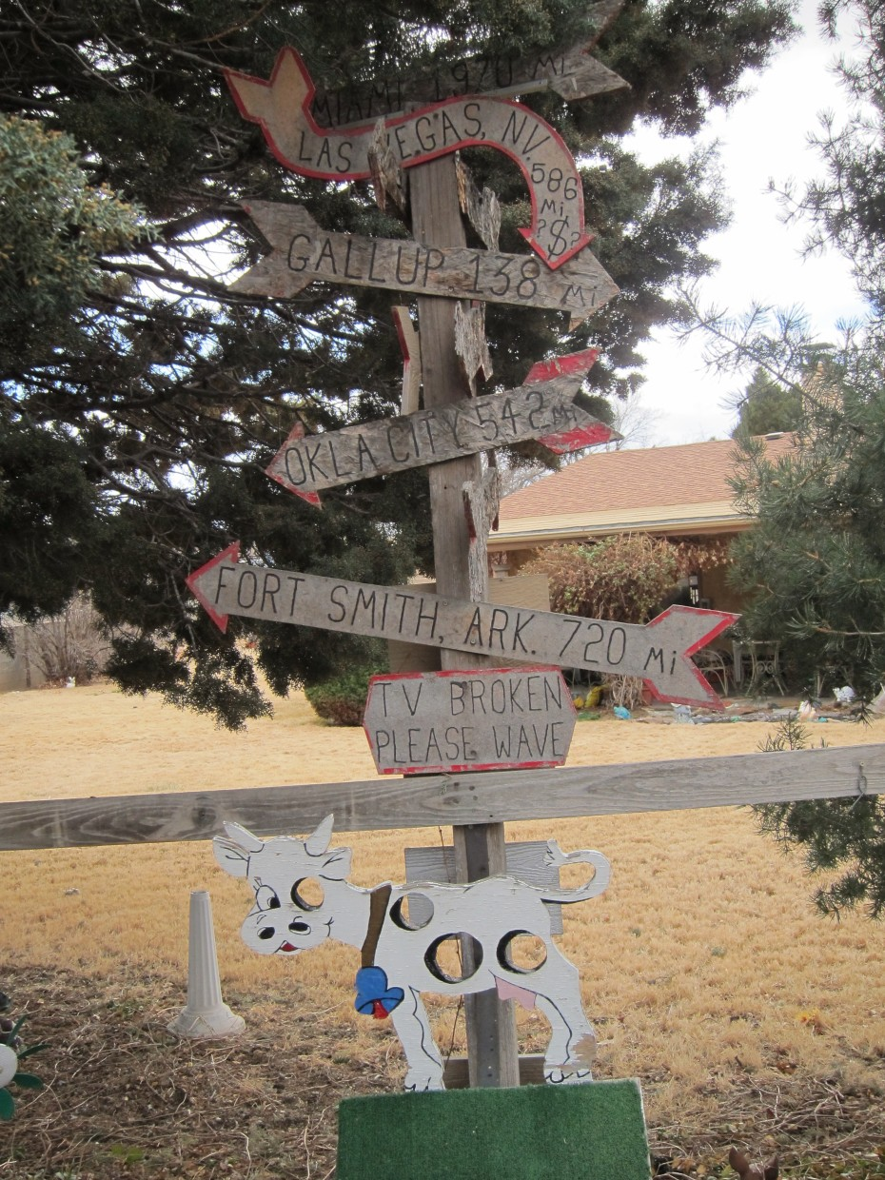
Moon Street. Moon’s bike lane runs north to Comanche, where you can continue on bike routes as far north as North Pino Arroyo (see map). To the south, Moon’s bike lane ends at Constitution, and connecting bike routes take you over I-40 via a bicycle and pedestrian overpass into Los Altos Park. From the park, bike routes continue to a point several blocks south of Central.
3.2 Miles
2.4 Miles

Gill’s book notes that members of the Moon family are long time residents of the city. Z. B. Moon was a state senator in the 1930’s.
Back Yard Between Moon And Wyoming

Wyoming Boulevard. A protected median allows you to cross one side at a time. If you are heading west, before you cross the southbound side verify there is no traffic in the frontage road which is adjacent to and west of the southbound lanes.
3.7 Miles
1.9 Miles
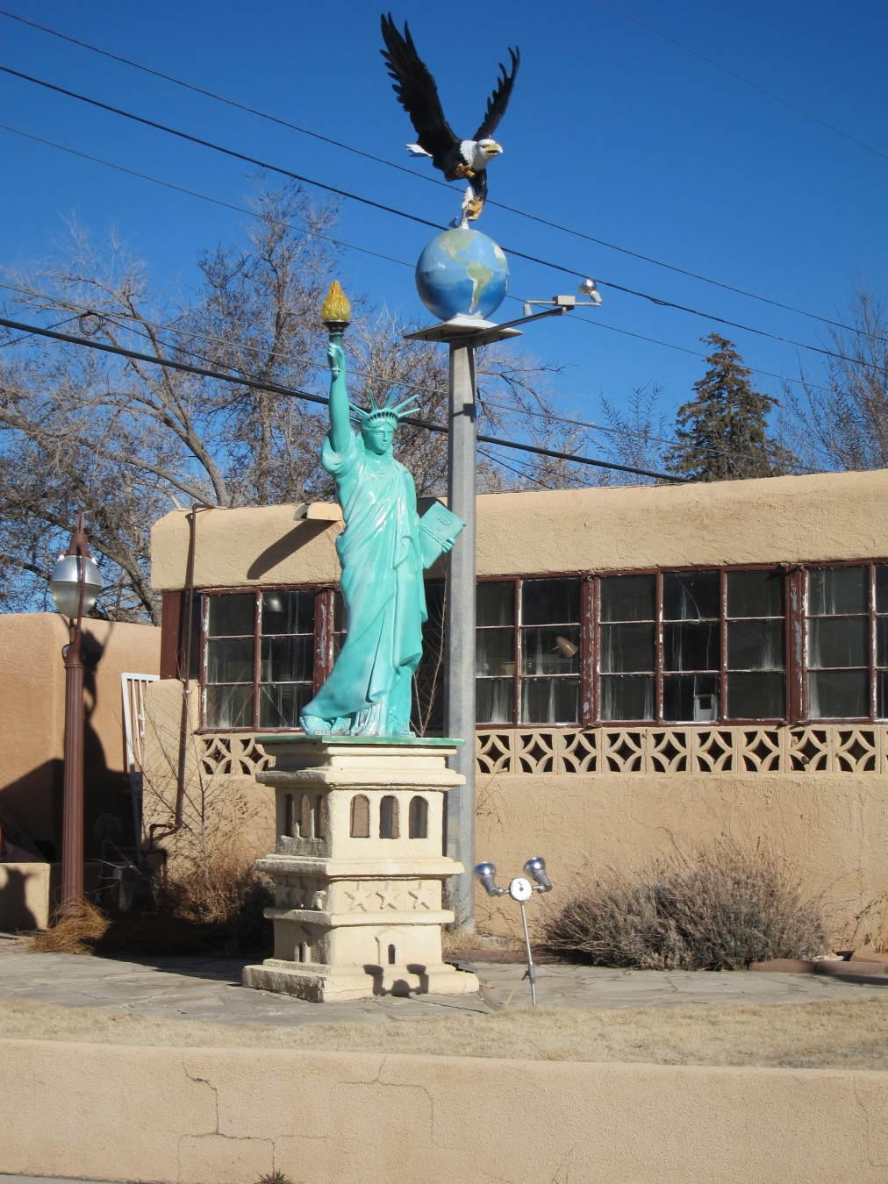
Wyoming Boulevard is part of the network of Northeast Heights arterials, a grid whose streets run north-south and east-west and are spaced one mile apart. One might ask how this pattern came to be placed in its present location and why it does not extend to downtown and the valley. To answer these questions one must return to the early days of American independence and to the somewhat later period of westward expansion.
Seeing the need to accurately identify land that would someday be sold or otherwise used by the government and its citizens, the fledgling Congress in 1785 passed the Land Ordinance, which established the basis for the Public Land Survey System. The federal government then hired surveyors to do the required field work of creating a grid of survey lines, and placing survey markers on the ground.
Just off the trail on Haines Ave., two doors west of Wyoming. Haines is just north of the trail.

In 1855, U S Deputy Surveyor John W. Garretson, working under the supervision of William Pelham, surveyor general for the New Mexico territory, began the New Mexico survey, using a starting point on Black Butte, a small hill near the village of San Acacia, 65 miles south of Albuquerque. Exactly why Pelham chose this starting point is not clear. Fred Roeder, retired NM surveyor and author, reviewed Garretson’s field notes, and points out that Washington officials—who knew little of the territory’s geography—designated several possible starting points north of the butte, but also allowed Pelham considerable leeway in choosing the location. For whatever reasons, Pelham chose Black Butte, and Garretson started his survey there. As required by the Public Land Survey System, parcels enclosed by these survey lines were laid out in sections, (squares measuring a mile on each side), and townships, (squares measuring six sections on a side); sections were further subdivided as needed. This system of sections and townships was eventually extended to the area now occupied by Albuquerque, and when Northeast Heights development was planned, the survey grid was used to determine the location of the major roads. For a more detailed explanation of the Public Land Survey System, see https://en.wikipedia.org/wiki/Public_Land_Survey_System .
As for downtown, its roads were laid out parallel to the railroad tracks, (at an angle of 9 degrees east of north), long before the northeast part of the city was developed.
Pennsylvania Street. Pennsylvania’s bike lane runs as far south as Lomas Boulevard; using connecting routes, you can reach Southern Avenue, south of Central. To the north, Pennsylvania’s bike lane extends to Osuna Road and its extensive network of connecting lanes and trails.
4.2 Miles
1.4 Miles
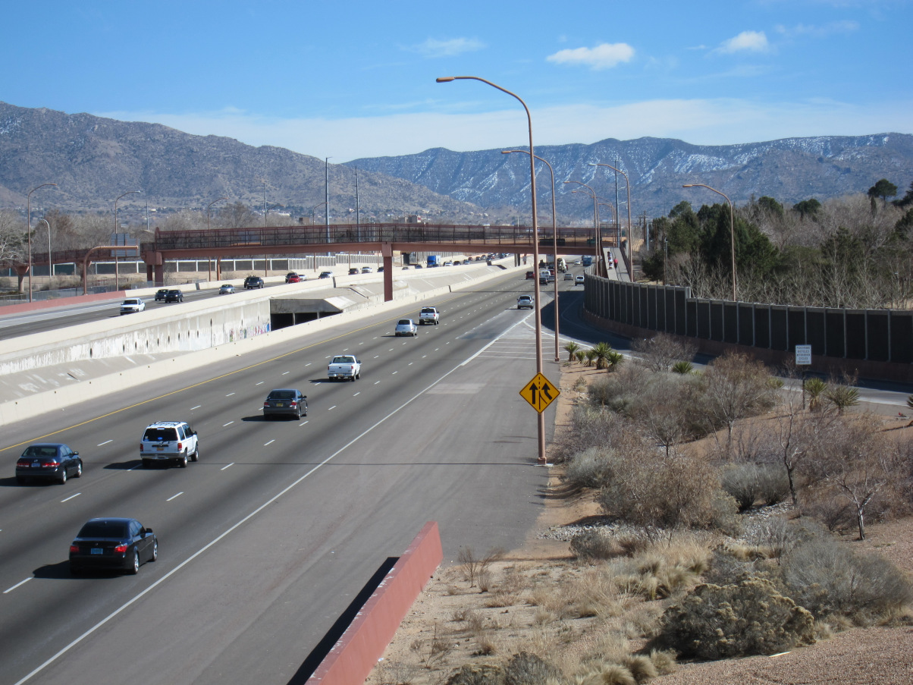
Turn right on Pennsylvania, go over the bridge over the arroyo, and immediately turn left, continuing along the northwest side of the arroyo.
Louisiana/I-40 Bicycle-Pedestrian Overpass
The small shaded area between the east and west bound lanes is Embudo Arroyo, emerging to run westward.

I-40 Bicycle/Pedestrian Overpass. Bear left and continue over the bike/pedestrian overpass. Embudo Arroyo runs under west bound I-40 and then between the east and west bound lanes. The cement-walled arroyo then continues west between lanes of the freeway to a point between Carlisle and Washington, where it is diverted away from I-40 and eventually into the North Diversion Channel.
4.5 Miles
1.1 Miles
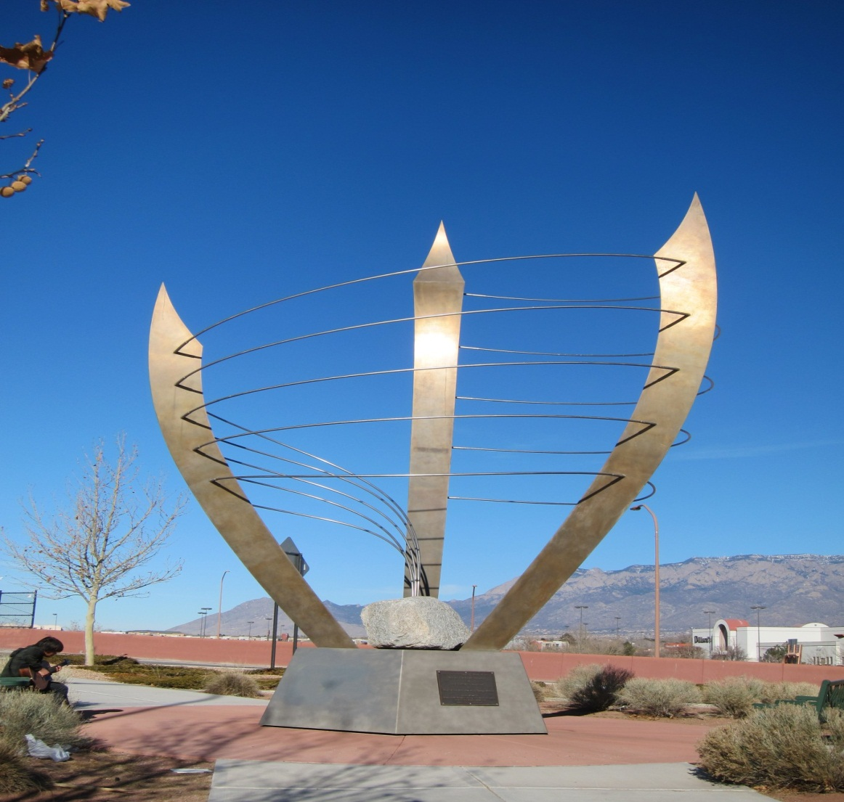
Jerry Cline Park. The trail follows the north and west sides of this large and popular park. Amenities include a playground, shade, picnic tables, playing fields, tennis courts, and parking. Although the tour continues to San Pedro, this might be a good spot to park a car if you are starting at the west end. A little before the path takes a sharp left, look up the embankment to the northwest and you’ll see the public art piece, Positive Energy of New Mexico, located at the junction of Louisiana and the eastbound I-40 on ramp. For a description of the city’s One Per Cent For The Arts program, see the Tramway Tour.
4.7 Miles
0.9 Miles
Louisiana Bicycle Pedestrian Underpass. Take a sharp right and go through the underpass beneath Louisiana Boulevard. Beyond the underpass, the path follows the Tom Bolack Urban Forest City Park. See the I-40 Trail for a description of this park. The path takes a sharp left before arriving at the fence for the dog park.
Positive Energy Of New Mexico

4.9 Miles
0.7 Miles
Leave the park and turn right (west) on Zimmerman Avenue. Street side parking is available here. Continue west on Zimmerman.
5.3 Miles
0.3 Miles

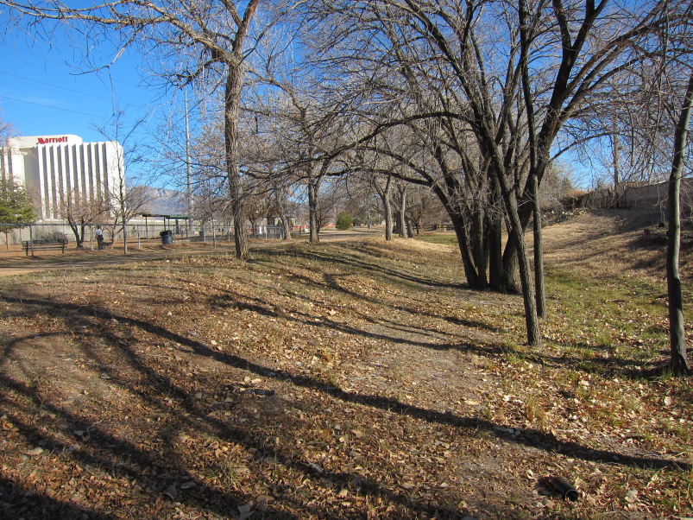
Tom Bolack Urban Forest City Park

San Pedro Drive. The tour ends here. You can continue west on Indian School Road, which requires a right turn on a very brief bike path parallel to San Pedro and then a quick left on Haines Avenue at the stoplight. Then take another quick right at Indian School.
5.6 Miles
0.0 Miles
Embudo Arroyo Side Trip
As an alternative to the start at Piedra Lisa Arroyo, one can begin the trip at Embudo Arroyo, about 0.8 miles to the south of Piedra Lisa.

East side of wooden overpass on Tramway Boulevard. The east side of the overpass is on the Tramway Trail, 0.7 miles north of Indian School Road and 0.5 miles south of Menaul Boulevard. Both streets have parking at their end points, both less than a mile east of Tramway.
- Miles From Tramway Blvd.
  - Miles From Morris Street
Go over the overpass and continue west past Crestview Heights Park. Curbside parking is available along the north side of the park. Near the west end of the park, go over the bicycle/pedestrian bridge crossing Embudo Arroyo and head straight down the trail along the arroyo.
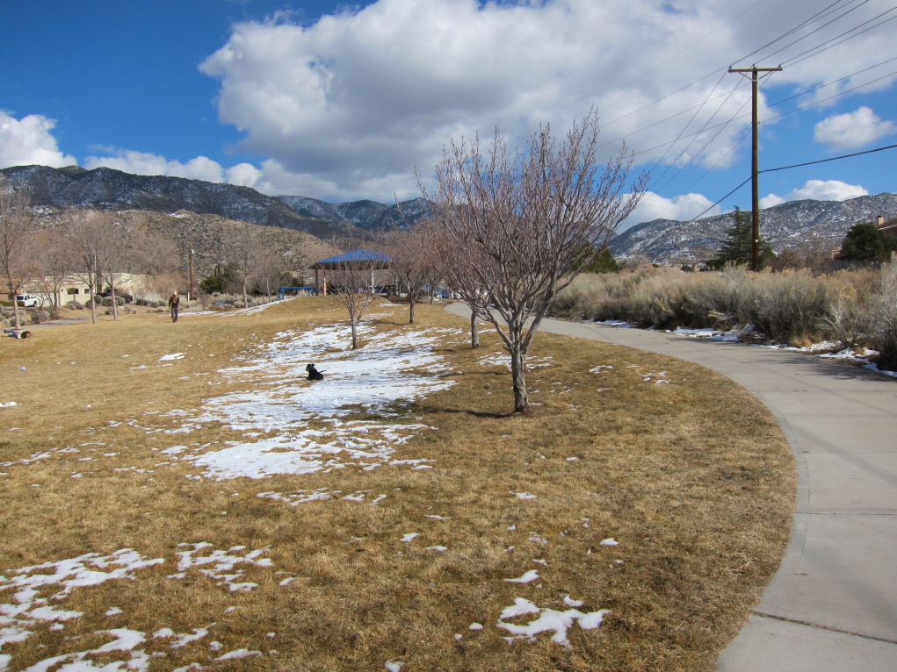
Crestview Heights Park

Chelwood Park Boulevard. A bike lane for much of Chelwood along with connecting bike routes provides access to Tramway and Montgomery Boulevards to the north and Tramway, Cloudview Avenue, and Encantado Road to the south.
0.6 Miles
1.1 Miles
Just east of Chelwood Park Boulevard the path diverges from its route between homes and runs alongside Indian School Road. From here to Juan Tabo Boulevard, the immediate surroundings are not particularly scenic, but the longer view--down the sloping heights, across the valley and up the West Mesa--is an impressive one, stimulating questions about how the area was formed.
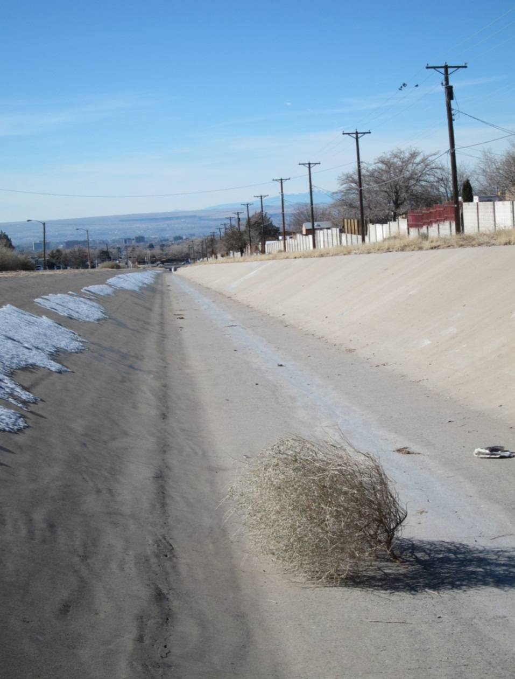
The Rio Grande Valley is not a valley in the technical sense. That is, it was not formed by its river. Rather, it is a rift valley, caused by subsidence of the valley floor and uplift of the West Mesa and the Sandias. The fractures in the earth’s crust where this movement occurs are known as faults. River valleys are carved by a river, but In the case of our rift, the faulting with its subsidence and uplift came first, and then the Rio Grande flowed through it.
On the east side of the rift the total vertical offset, accumulated over many millions of years, is quite large. The same rock layer found near Sandia Crest can also be found 20,000 feet below the valley floor. When you add the crest’s elevation of 5,000 feet above the valley floor, you have a total vertical movement of about 5 miles! Faulting is still active, though the rate of movement is imperceptible and most of the fault lines are deeply buried. For a more detailed look at our rift, see Roadside Geology of New Mexico, by Halka Chronic and Field Guide To The Sandia Mountains, edited by Robert Julyan and Mary Stuever.
Looking West, Down Embudo Arroyo

As the mountains rose up and the valley subsided, the increased relief was partly offset by erosion, which brought rocks and sand down from the highlands into the lower elevations. These sediments now lying beneath our feet as well as those on the valley floor are enormously important to us, since they hold and transmit much of Albuquerque’s drinking water.
Juan Tabo Boulevard. Just west of here the trail turns northwest, away from Indian School Road to again run between houses.
1.2 Miles
0.5 Miles

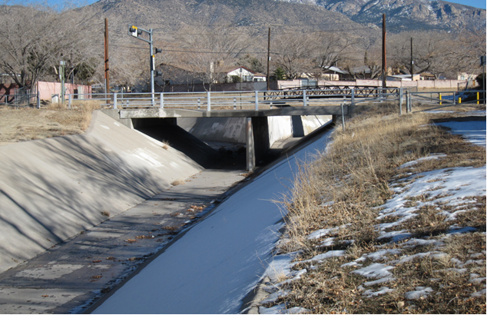
Junction of Embudo and Piedra Lisa Arroyos

Junction Paseo de las Montañas/Morris Street. Rejoin the main route here.
1.7 Miles
0.0 Miles

Thanks for your help: Jayne Aubele, Ed Boles, Hector Cruz, Carol Dumont, Jay Evans, Brandon Griffith, Lynne Martin, David Mitchell, John Pacheco, Fred Roeder, Janet Saiers, Robert Trudo, Stephani Winklepleck.

Photo Credits: All photos by the authors.

This trail’s guide was carefully researched and written by Marshall Kovitz in 2012. It was revised slightly in May 2020.

